New Decoz Numerology Master program upgrade

I am designing a new front end, so for now, just use something generic.

- Installs on PC and Mac desktops – later maybe on mobiles, or have a minimized version for mobiles.
- A 100% fully functional trial version that creates sample reports on the fly, exactly as the activated version would, but based only on a dozen or so names and birthdates that can’t be altered.
- Customizable covers
- Customizable introductions
- Allows for report generation without Internet connection but requires a verification once a month or is disabled.
- Copyright protection notices on the bottom of every page.
- Title pages that can’t be altered – at least not easily following PDF output.
- Requires internet connection for updates, and access to some files, like cover design changes, customized introduction changes, and monthly verification.
- All text content databases (or whatever format we use) should be and whatever else is needed to create a report, should be installed on the desktop.
- Multiple languages, most likely by duplicated text databases with other languages, unless there is a “Translate this” feature built in? I am assuming that would require an Internet connection?
- Text/Content should be encrypted to prevent copyright issues.
- Reports generated should be saved on the computer only.
- The following reports should be included with extensive customization – an example shown on these dialog boxes – I love the simplicity of these dialog boxes, and that you can control so much from each dialog box: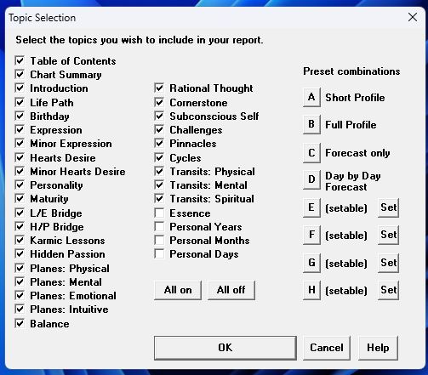
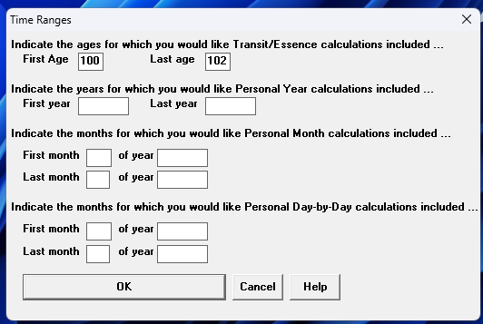
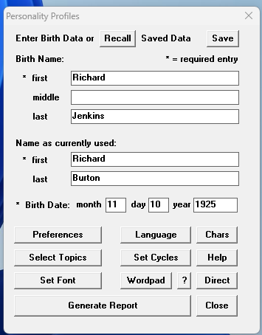
  - Personality Profile – include/exclude every topic 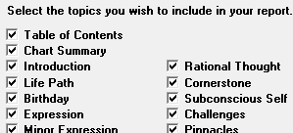
save preferred selections in presets
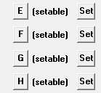,
and have presets already included
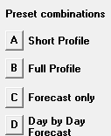
  - Yearly Forecast – include/exclude every topic, set cycle durations – see first dialog box above, which covers both profiles and forecasts
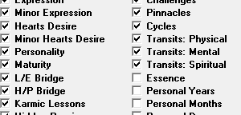
But has a separate dialog box for setting the lengths of cycles.
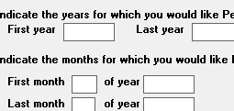
  - Relationship Profile and Forecast – include/exclude every topic – set cycle durations (a lot less topics and cycles are included than Personal Profiles and Forecasts)
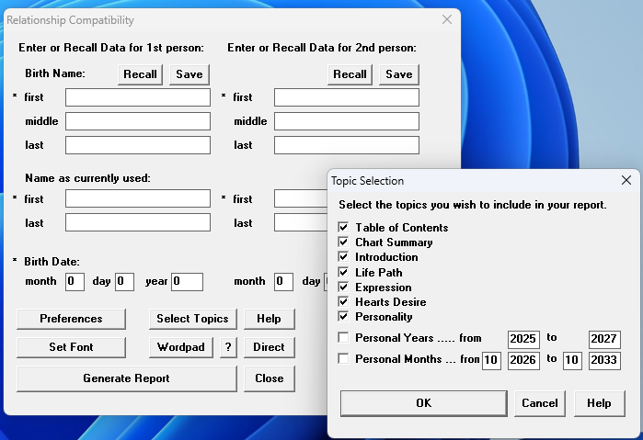
  - Diamond Reading - only customization is setting the number of years (not months) to include in a report.
  - Lucky Numbers - only customization is setting the number of months and years to include in a report.
  - Chart Calculator - only customization is setting the number of months and years to include.
- The following reports would have no customization options – they are just like the ones we produce on the site:
  - Talent Profile
  - Ancestral Influences
  - Inner Reflection reading
  - Name Advisor for Business
  - Name Advisor for People
  - Address Analyzer
  - Phone Number Analyzer
  - Lost Object Finder
  - Address Analyzer
  - Proportional Chartmaker
  - Decoz Color Chartmaker
- Some customization that is not in the Online program or the web app:
Select from three different options how to calculate the Life Path – would apply to all readings that include Life Paths:
  - Personality Profile
  - Relationship Profiles
- Some customization that is in the old Decoz Numerology Master program, but we may not need or save for a later update: Formatting options, output options. (PDF only)
- Features to include that are similar to the web app:
  - SAVED READINGS
  - SAVED BIRTH DATA

From the admin I should be able to control the following:
- Disable/Enable users
- Delete/Restore users
- Track usage (number of reports created by each professional – not to control, just for the data)
- Activation codes? Or just use Disable/Enable?
- Comments or notes I can store with each user
- Notifications

