New Decoz Numerology Master program upgrade
I am designing a new front end, so for now, just use something generic. Please devote as little time to the interface as needed, use place holders, basically
Look at the old Master program regularly – I want the new one to be very similar, but greatly expanded.

1. Installs on PC and Mac desktops – later maybe on mobiles, or have a minimized version for mobiles.
2. A 100% fully functional trial version that creates sample reports on the fly, exactly as the activated version would, but based only on a dozen or so names and birthdates that can’t be altered.
3. Customizable covers
4. Customizable introductions
5. Allows for report generation without Internet connection but requires a verification once a month or is disabled.
6. Copyright protection notices on the bottom of every page.
7. Title pages that can’t be altered – at least not easily following PDF output.
8. Requires internet connection for updates, and access to some files, like cover design changes, customized introduction changes, and monthly verification.
9. All text content databases (or whatever format we use) should be and whatever else is needed to create a report, should be installed on the desktop.
10.Multiple languages, most likely by duplicated text databases with other languages, unless there is a “Translate this” feature built in? I am assuming that would require an Internet connection? Thoughts?
11.Text/Content should be encrypted to prevent copyright issues.
12.Reports generated should be saved on the computer only. No copies on the server.
13.The following reports should be included with extensive customization – an example shown on these dialog boxes – I love the simplicity of these dialog boxes, and that you can control so much from each dialog box to (Not all reports require customization this specific, only Personality Profiles and Future Forecasts – Relationship reports, Diamond Report, Lucky Numbers, to a lesser extent):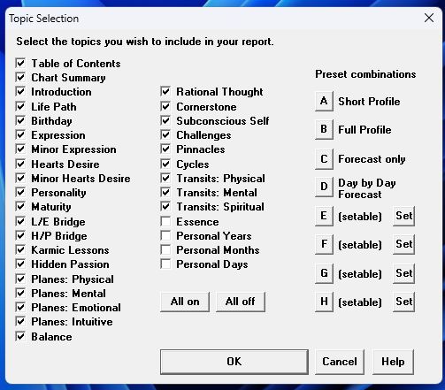
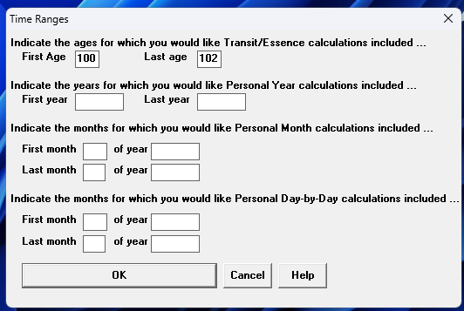
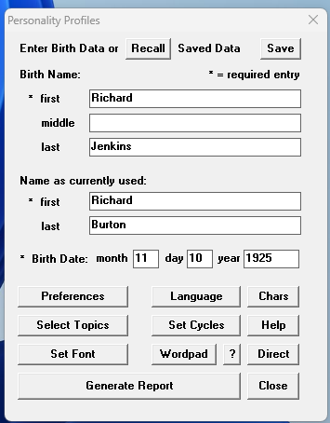
a. Personality Profile – include/exclude every topic 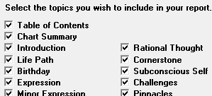
save preferred selections in presets
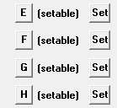,
and have presets already included
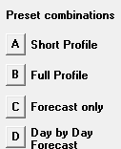
b. Yearly Forecast – include/exclude every topic, set cycle durations – see first dialog box above, which covers both profiles and forecasts
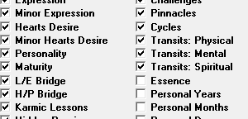
But has a separate dialog box for setting the lengths of cycles.
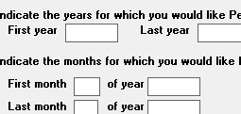
c. Relationship Profile and Forecast – include/exclude every topic – set cycle durations (a lot less topics and cycles are included than Personal Profiles and Forecasts)
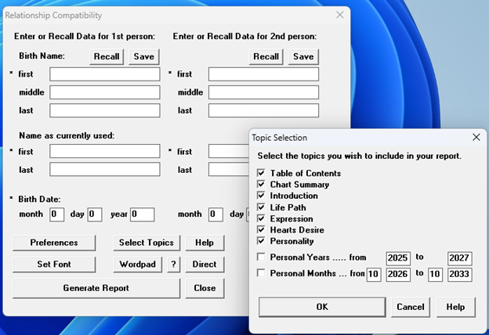
d. Diamond Reading - only customization is setting the number of years (not months) to include in a report.
e. Lucky Numbers - only customization is setting the number of months and years to include in a report.
f. Chart Calculator - only customization is setting the number of months and years to include.
14.The following reports would have no customization options – they are just like the ones we produce on the site:
a. Talent Profile
b. Ancestral Influences
c. Inner Reflection reading
d. Name Advisor for Business
e. Name Advisor for People
f. Address Analyzer
g. Phone Number Analyzer
h. Lost Object Finder
i. Proportional Chartmaker
j. Decoz Color Chartmaker
15.Some customization that is not in the Online program or the web app:
Select from three different options how to calculate the Life Path – would apply to all readings that include Life Paths:
a. Personality Profile
b. Relationship Profiles
16.Also: User should be able to select include or exclude the images – the numbers in circles that we have in our reports.
17.Some customization that is in the old Decoz Numerology Master program, but we may not need or save for a later update: Formatting options, except font size and font type – we need that, output options. (PDF only)
18.Features to include that are similar to the web app:
a. SAVED READINGS
b. SAVED BIRTH DATA (including partners in relationship reports)

From the admin I should be able to control the following:
I. Disable/Enable users
II. Delete/Restore users
III. Track usage (number of reports created by each professional – not to control, just for the data)
IV. Activation codes? Or just use Disable/Enable?
V. Comments or notes I can store with each user
VI. Notifications

